Lab Exercise - Ansible Role

Create an Ansible Role
Step 1: Create a working directory
mkdir ansible-roles-lab
cd ansible-roles-lab
Step 2: Use ansible-galaxy to create a role
ansible-galaxy init apache_role
This creates the role structure:
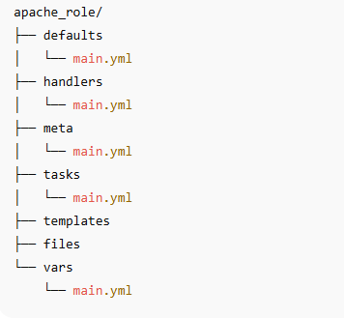

Configure the Role (Install Apache)
Step 1: Edit tasks
Open:
nano apache_role/tasks/main.yml
Add:
---
- name: Install Apache
apt:
name: apache2
state: present
update_cache: yes

- name: Change Apache listen port to 8081
lineinfile:
path: /etc/apache2/ports.conf
regexp: '^Listen '
line: 'Listen 8081'

- name: Update VirtualHost port
lineinfile:
path: /etc/apache2/sites-enabled/000-default.conf
regexp: '^<VirtualHost '
line: '<VirtualHost *:8081>'

- name: Restart Apache
service:
name: apache2
state: restarted
enabled: yes
Step 2: Add a handler (optional)
Open:
nano apache_role/handlers/main.yml
Add:
---
- name: restart apache
service:
name: apache2
state: restarted

Create the Playbook that Uses the Role
Create a playbook
nano install_apache.yml
Add:
---
- hosts: localhost
become: yes
roles:
- apache_role

Run the Role
Execute the playbook:
ansible-playbook install_apache.yml

Verify the Role Execution
Step 1: Check Apache status
systemctl status apache2
Step 2: Check if Apache is running
curl http://localhost:8081
If working, you should see:
<!DOCTYPE html>
<html>
<head>
<title>Apache2 Ubuntu Default Page...</title>
</head>
...

Modify Role Variables (Optional)
Step 1: Add a message variable
Edit:
nano apache_role/vars/main.yml
Add:
welcome_message: "Hello from Ansible Role!"
Step 2: Use the variable in a template
Create:
nano apache_role/templates/index.html.j2
Add:
<html>
<body>
<h1>{{ welcome_message }}</h1>
</body>
</html>

Step 3: Add template deployment task
Edit:
nano apache_role/tasks/main.yml
update the file:
---
- name: Install Apache
apt:
name: apache2
state: present
update_cache: yes

- name: Change Apache listen port to 8081
lineinfile:
path: /etc/apache2/ports.conf
regexp: '^Listen '
line: 'Listen 8081'

- name: Update VirtualHost port
lineinfile:
path: /etc/apache2/sites-enabled/000-default.conf
regexp: '^<VirtualHost '
line: '<VirtualHost *:8081>'

- name: Restart Apache
service:
name: apache2
state: restarted
enabled: yes

- name: Deploy custom index page
template:
src: index.html.j2
dest: /var/www/html/index.html
notify:
- restart apache
Step 4: Re-run playbook
ansible-playbook install_apache.yml
Step 5: Verify
curl http://localhost:8081
Expected output:
<html>
<body>
<h1>Hello from Ansible Role!</h1>
</body>
</html>

